Bahria University,

Karachi Campus



COURSE: CSC-221 DATA STRUCTURES AND ALGORITHM

TERM: FALL 2019, CLASS: BSE- 3 (B)

Submitted By:

____SYED ALI ABBAS________________02-131182-070____

(Name) (Reg. No.)

Submitted To:

Engr. Bushra Fazal/ Engr. Saniya Sarim

Signed Remarks: Score:

INDEX

|  |  |  |  |  |
| --- | --- | --- | --- | --- |
| SNO | DATE | LAB NO | LAB OBJECTIVE | SIGN |
| 1. | 15/09/19 | Lab#1 | ARRAYS |  |
| 2. |  | Lab#2 |  |  |
| 3. |  | Lab#3 |  |  |
| 4. |  | Lab#4 |  |  |
| 5. |  | Lab#5 |  |  |
| 6. |  | Lab#6 |  |  |
| 7. |  | Lab#7 |  |  |
| 8. |  | Lab#8 |  |  |
| 9. |  | Lab#9 |  |  |
| 10. |  | Lab#10 |  |  |
| 11. |  | Lab#11 |  |  |
| 12. |  | Lab#12 |  |  |
| 13. |  | Lab#13 |  |  |
| 14. |  | Lab#14 |  |  |
| SNO | DATE | LAB NO | LAB OBJECTIVE | SIGN |
| 15. |  | Lab#15 |  |  |
| 16. |  | Lab#16 |  |  |
| 17. |  | Lab#17 |  |  |
| 18. |  | Lab#18 |  |  |
| 19. |  | Lab#19 |  |  |
| 20. |  | Lab#20 |  |  |
| 21. |  | Lab#21 |  |  |
| 22. |  | Lab#22 |  |  |
| 23. |  | Lab#23 |  |  |
| 24. |  | Lab#24 |  |  |
| 25. |  | Lab#25 |  |  |
| 26. |  | Lab#26 |  |  |
| 27. |  | Lab#27 |  |  |
| 28. |  | Lab#28 |  |  |
| 29. |  | Lab#29 |  |  |

Bahria University,

Karachi Campus



LAB EXPERIMENT NO.

___01____

LIST OF TASKS

|  |  |
| --- | --- |
| TASK NO | OBJECTIVE |
| QUESTION NO.1 | Create an array of length 10 of integers. Values ranging from 1 to 50.  1. Find all pair of elements whose sum is 25.  2. Find the number of elements of A which are even, and the number of elements of A which are odd.  3. Write a procedure which finds the average of the value of A.  4. Write a procedure which adds an element in an array at a given index. Take the value to add and the index from the user by using Shift down technique.   1. Write a procedure which looks for 2 numbers 45 and 14 in an array and delete them if they are present in the array by using Shift up technique. |
| QUESTION NO.2 | Write a program which input 2 matrix of user defined rows and columns and perform following operation  a. Display/Print as a Matrix  b. Addition of Matrix  c. Subtraction of Matrix  d. matrix multiplication  e. Determinant  f. Inverse |
| QUESTION NO.3 |  |
| QUESTION NO.4 |  |
| QUESTION NO.5 |  |
| QUESTION NO.6 |  |

Submitted On:

___18_/ 09/2019___

(Date: DD/MM/YY)

**QUESTION : 1** Create an array of length 10 of integers. Values ranging from 1 to 50.

1. Find all pair of elements whose sum is 25.

2. Find the number of elements of A which are even, and the number of elements of A which are odd.

3. Write a procedure which finds the average of the value of A.

4. Write a procedure which adds an element in an array at a given index. Take the value to add and the index from the user by using Shift down technique.

1. Write a procedure which looks for 2 numbers 45 and 14 in an array and delete them if they are present in the array by using Shift up technique.
2. **CODE:**

int[] arrayNumber=new int[10];

for (int i = 0; i <10 ; i++)

{

Console.WriteLine("Enter numbers");

arrayNumber[i] = Convert.ToInt32(Console.ReadLine());

if (arrayNumber[i] >= 50) {

Console.WriteLine("Out Of Range");

break;

}

}

int c = 0;

for (int i = 0; i < 10; i++)

{

for (int j = 0; j < 10; j++)

{

c = arrayNumber[i] + arrayNumber[j];

if (c == 25)

{

Console.WriteLine();

Console.WriteLine("Index Number" + i + " & " + j + "have sum

equal to " + c);

}

}

}

**run:**

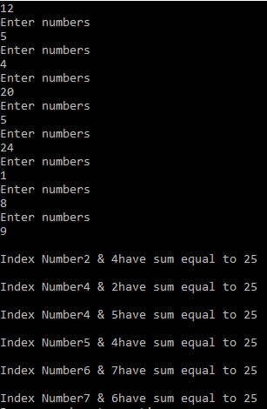

1. **CODE:**

int[] evenOdd=new int[10];

for (int i = 0; i < 10; i++)

{

Console.WriteLine("Enter the number of index {0} :",i);

evenOdd[i] = Convert.ToInt32(Console.ReadLine());

}

for (int i = 0; i < 10; i++)

{

if (evenOdd[i] % 2 == 0)

{

Console.WriteLine("Even value {0} is having index number {1}" , evenOdd[i] , i);

}

}

Console.WriteLine("\n");

for (int j = 0; j < 10; j++)

{

if (evenOdd[j] % 2 != 0)

{

Console.WriteLine("Odd value {0} is having index number {1}", evenOdd[j],j);

}

}

**run:**

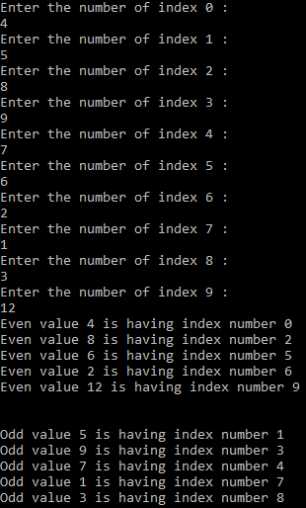

1. **CODE:**

int[] array = new int[10];

for (int i = 0; i < 10; i++)

{

Console.Write("Enter the number's for making average on index [{0}] : ",i,"");

array[i] = Convert.ToInt32(Console.ReadLine());

if (array[i]>50)

{

Console.WriteLine("Value oue of range");

break;

}

}

double c = 0 , d = 0;

for (int i = 0; i < 10; i++)

{

c += array[i];

}

d += c / array.Length;

Console.WriteLine("Total Sum of numbers you had entered are {0}",c);

Console.WriteLine("Average of the given value is {0}", d);

**run:**

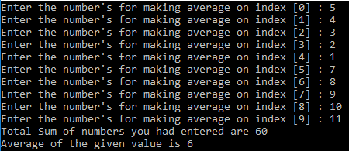

1. **CODE:**

int[] arr1 = new int[10];

int p = 0;

Console.Write("\n\nInsert New value in the sorted array :\n");

Console.Write("-----------------------------------------\n");

Console.Write("Input the size of array : ");

int n = Convert.ToInt32(Console.ReadLine());

Console.Write("Input {0} elements in the array in ascending order:\n", n);

for (int i = 0; i < n; i++)

{

Console.Write("element - {0} : ", i);

arr1[i] = Convert.ToInt32(Console.ReadLine());

}

Console.Write("Input the value to be inserted : ");

int inval = Convert.ToInt32(Console.ReadLine());

Console.Write("The exist array list is :\n ");

for (int i = 0; i < n; i++)

Console.Write("{0} ", arr1[i]);

for (int i = 0; i < n; i++)

if (inval < arr1[i])

{

p = i;

break;

}

for (int i = n; i >= p; i--)

arr1[i] = arr1[i - 1];

arr1[p] = inval;

Console.Write("\n\nAfter Insert the list is :\n ");

for (int i = 0; i <= n; i++)

Console.Write("{0} ", arr1[i]);

Console.Write("\n");

**run:**

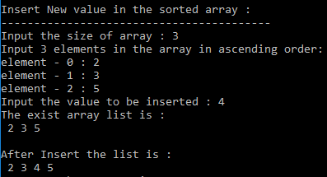

1. **CODE:**

int[] array = new int[10] {0,12,14,5,45,8,9,10,5,13};

int counter = 0;

for (int i = 0; i < array.Length; i++)

{

Console.WriteLine(array[i]);

}

for (int i = 0; i < array.Length; i++)

{

if ((array[i] != 14) && (array[i] != 45))

{

counter++;

Console.WriteLine("index {0} Enement Value is {1} ", counter - 1, array[i]);

}

}

**run:**

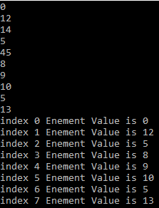

**QUESTION :**

Write a program which input 2 matrix of user defined rows and columns and perform following operation

a. Addition of Matrix

b. Subtraction of Matrix

c. matrix multiplication

d. Determinant

e. Inverse

1. **CODE:**

int[,] matrix1 = new int[2,2];

Console.WriteLine("MATRIX 1");

Console.WriteLine();

for (int i = 0; i < 2; i++)

{

for (int j = 0; j < 2; j++)

{

Console.WriteLine("Enter value for index :[{0},{1}]",i,j);

matrix1[i, j] = Convert.ToInt32(Console.ReadLine());

}

}

Console.WriteLine("\n");

Console.WriteLine("MATRIX 2");

Console.WriteLine();

int[,] matrix2 = new int[2, 2];

for (int i = 0; i < 2; i++)

{

for (int j = 0; j < 2; j++)

{

Console.WriteLine("Enter value for index :[{0},{1}]", i, j);

matrix2[i, j] = Convert.ToInt32(Console.ReadLine());

}

}

int[,] matrix3 = new int[2,2];

for (int i = 0; i < 2; i++)

{

for (int j = 0; j < 2; j++)

{

for (int k = 0; k < 2; k++)

{

matrix3[i, j] += matrix1[i, k] * matrix2[k, j];

}

}

}

for (int i = 0; i < 2; i++)

{

for (int j = 0; j < 2; j++)

{

Console.WriteLine("[{0},{1}]:{2}",i,j, matrix3[i,j]);

}

}

**run:**

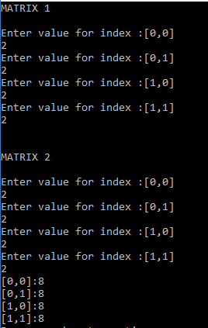

1. **CODE:**

int[,] matrix1 = new int[2,2];

Console.WriteLine("MATRIX 1");

Console.WriteLine();

for (int i = 0; i < 2; i++)

{

for (int j = 0; j < 2; j++)

{

Console.WriteLine("Enter value for index :[{0},{1}]",i,j);

matrix1[i, j] = Convert.ToInt32(Console.ReadLine());

}

}

Console.WriteLine("\n");

Console.WriteLine("MATRIX 2");

Console.WriteLine();

int[,] matrix2 = new int[2, 2];

for (int i = 0; i < 2; i++)

{

for (int j = 0; j < 2; j++)

{

Console.WriteLine("Enter value for index :[{0},{1}]", i, j);

matrix2[i, j] = Convert.ToInt32(Console.ReadLine());

}

}

int[,] matrix3 = new int[2,2];

for (int i = 0; i < 2; i++)

{

for (int j = 0; j < 2; j++)

{

matrix3[i, j] += matrix1[i,j] + matrix2[i, j];

}

}

for (int i = 0; i < 2; i++)

{

for (int j = 0; j < 2; j++)

{

Console.WriteLine("[{0},{1}]:{2}",i,j, matrix3[i,j]);

}

}

**run:**

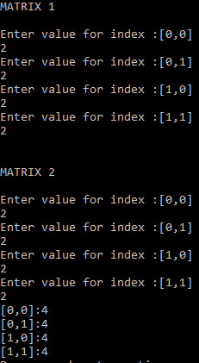

1. **CODE:**

int[,] matrix1 = new int[2,2];

Console.WriteLine("MATRIX 1");

Console.WriteLine();

for (int i = 0; i < 2; i++)

{

for (int j = 0; j < 2; j++)

{

Console.WriteLine("Enter value for index :[{0},{1}]",i,j);

matrix1[i, j] = Convert.ToInt32(Console.ReadLine());

}

}

Console.WriteLine("\n");

Console.WriteLine("MATRIX 2");

Console.WriteLine();

int[,] matrix2 = new int[2, 2];

for (int i = 0; i < 2; i++)

{

for (int j = 0; j < 2; j++)

{

Console.WriteLine("Enter value for index :[{0},{1}]", i, j);

matrix2[i, j] = Convert.ToInt32(Console.ReadLine());

}

}

int[,] matrix3 = new int[2,2];

for (int i = 0; i < 2; i++)

{

for (int j = 0; j < 2; j++)

{

matrix3[i, j] += matrix1[i,j] - matrix2[i, j];

}

}

for (int i = 0; i < 2; i++)

{

for (int j = 0; j < 2; j++)

{

Console.WriteLine("[{0},{1}]:{2}",i,j, matrix3[i,j]);

}

}

**run:**

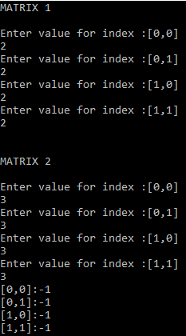

1. **CODE:**

double[,] matrix = new double[2, 2];

for (int i = 0; i < 2; i++)

{

for (int j = 0; j < 2; j++)

{

Console.WriteLine("Enter the Value for index [{0},{1}]", i, j);

matrix[i, j] = Convert.ToInt32(Console.ReadLine());

}

}

double determinent = 0;

determinent += matrix[0, 0] * matrix[1, 1] - matrix[0, 1] * matrix[1, 0];

Console.WriteLine("Determinent is {0}", determinent);

double one=0;

double inverse = 0;

Console.WriteLine("Inverse is");

for (int i = 1; i >=0; i--)

{

for (int j = 1; j >=0 ; j--)

{

inverse = (1 / determinent) * matrix[i, j];

Console.WriteLine(inverse);

}

}

**run:**

